Python flask app deployment on Azure using zip

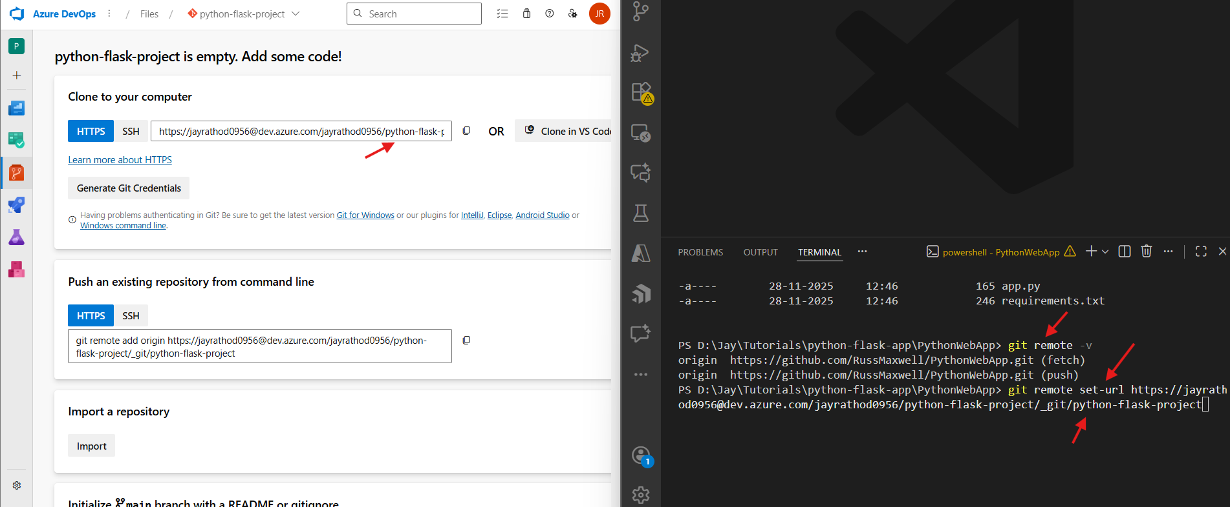
git remote set-url origin <url>
git remote -v
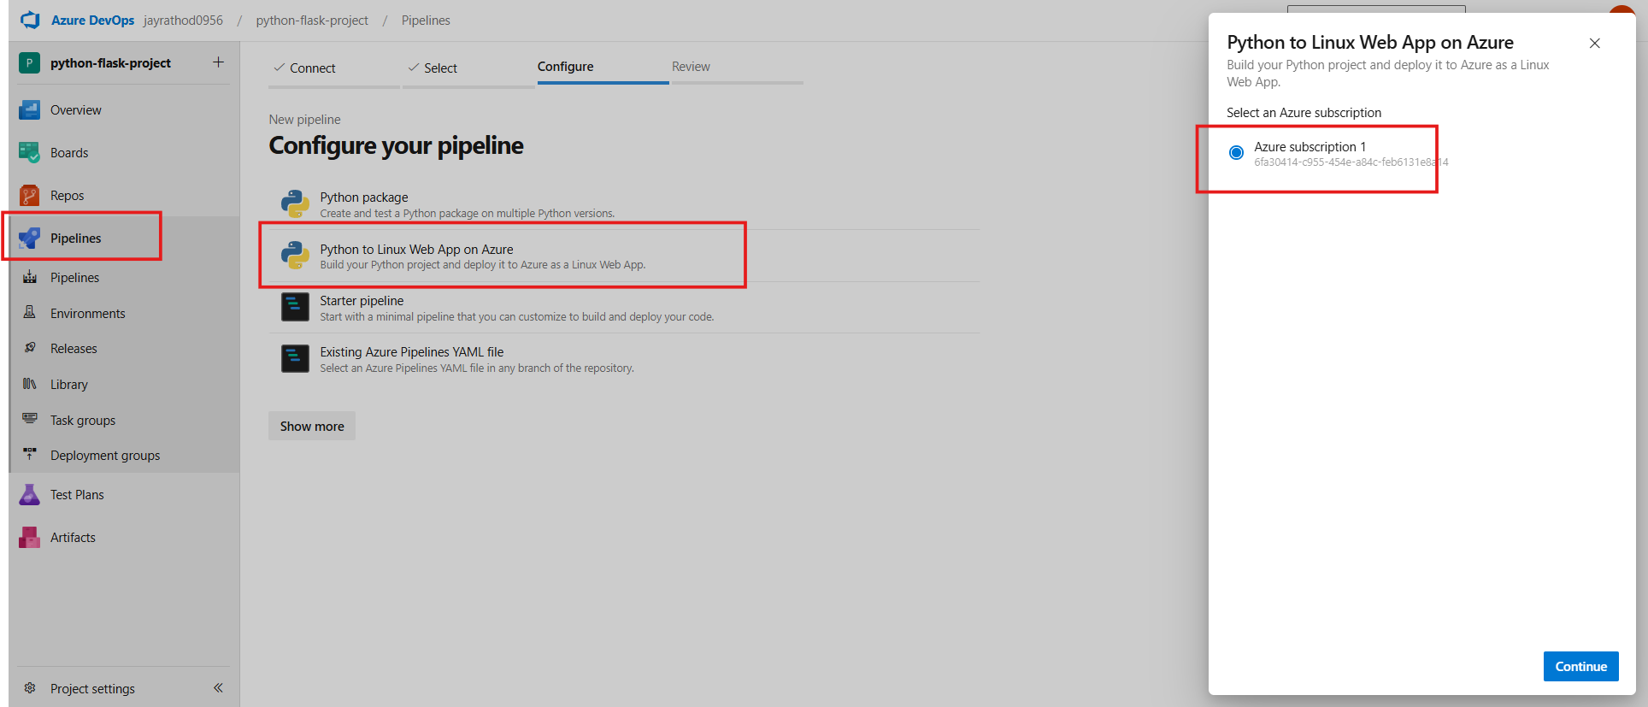

Website url
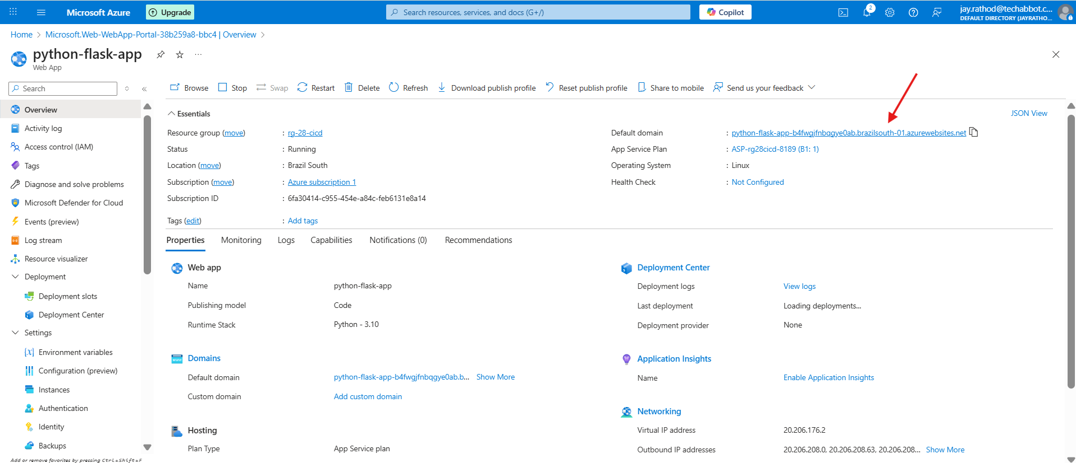

trigger:
- main

variables:
# Azure Resource Manager connection created during pipeline creation
azureServiceConnectionId: ‘123-456-789'

# Web app name
webAppName: 'python-flask-app'

# Agent VM image name
vmImageName: 'ubuntu-latest'

# Environment name
environmentName: 'python-flask-app'

# Project root folder. Point to the folder containing manage.py file.
projectRoot: $(System.DefaultWorkingDirectory)

pythonVersion: '3.11'
in case actual code is inside src folder
projectRoot: $(System.DefaultWorkingDirectory)/src

stages:Build
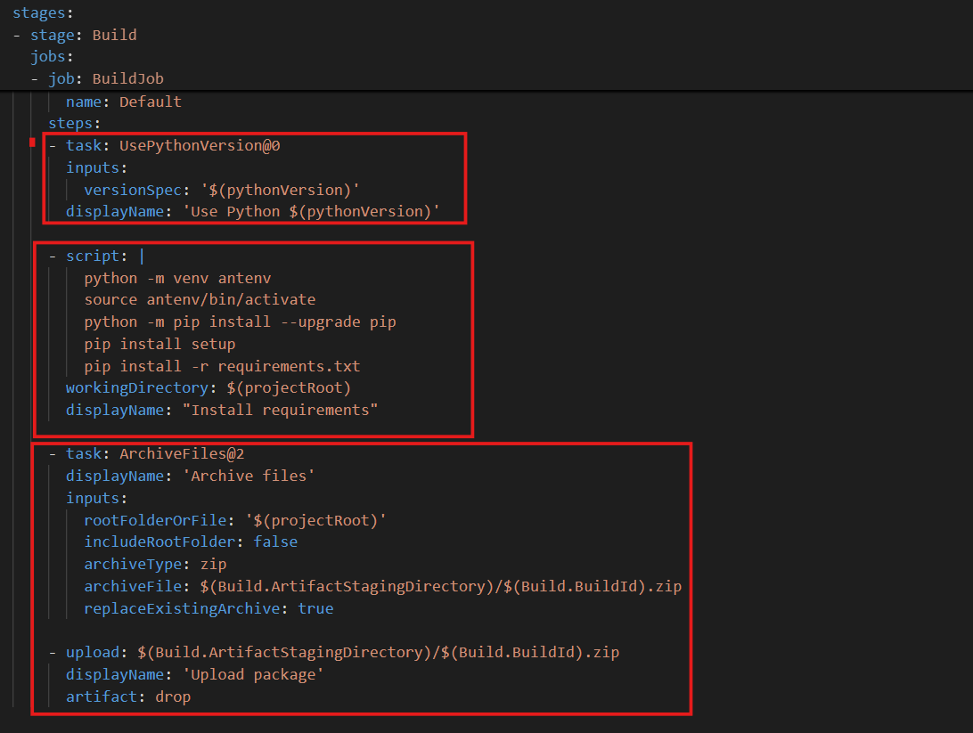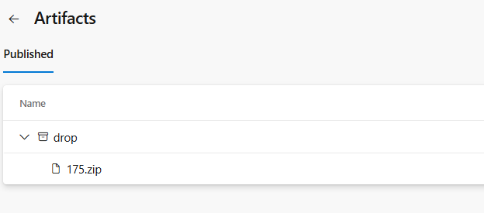
$(System.DefaultWorkingDirectory) -> /agent/_work/1/s
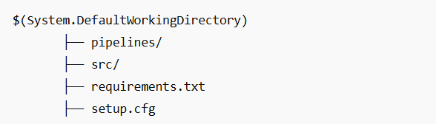
workingDirectory → where the script runs
includeRootFolder | ZIP contains
true | project/file1.py, project/file2.py
false | file1.py, file2.py

Deployment

This stage runs only if the Build stage succeeded.
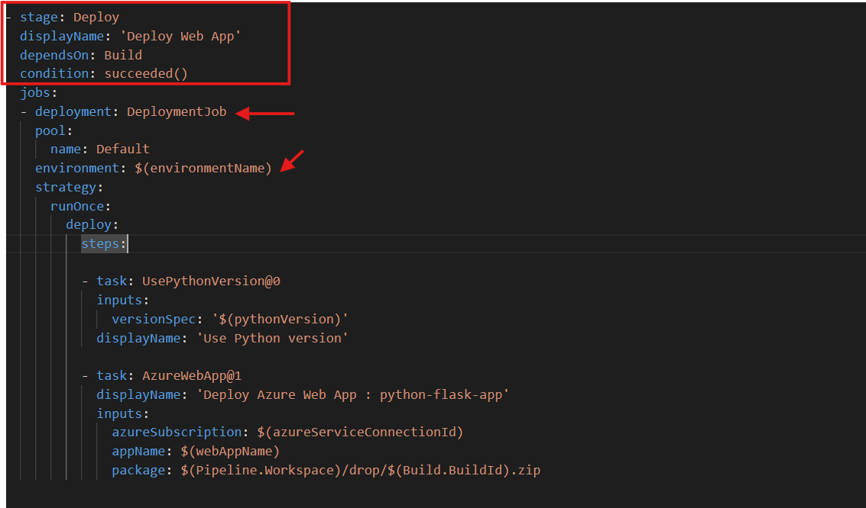
• Can track deployment history
• Deploys to the specified environment (Dev, Test, Prod)
UsePythonVersion@0 = Ensures the agent uses the correct Python version (same as in Build stage).
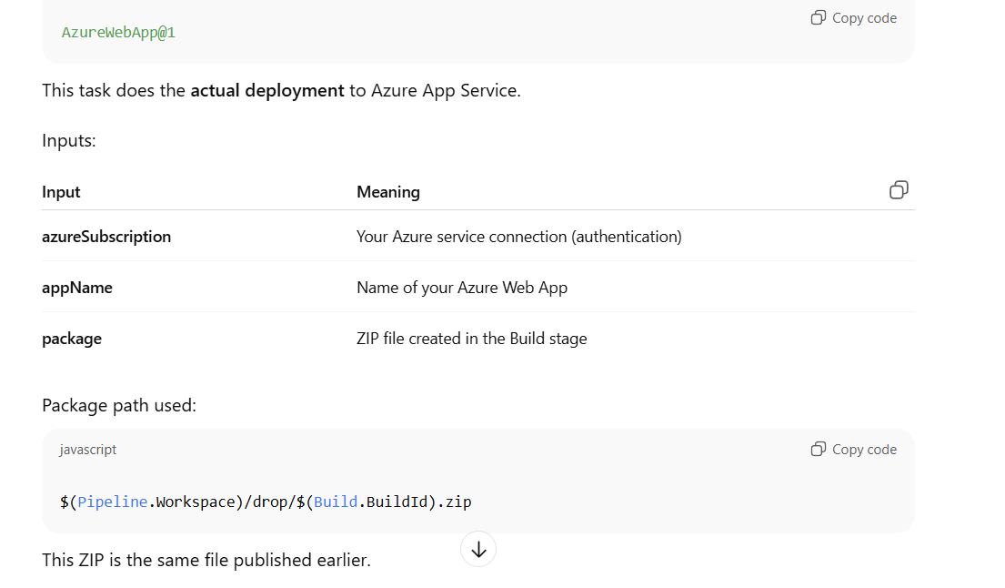
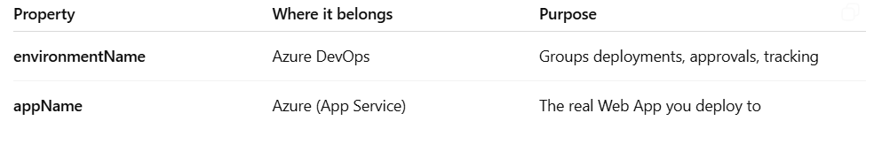
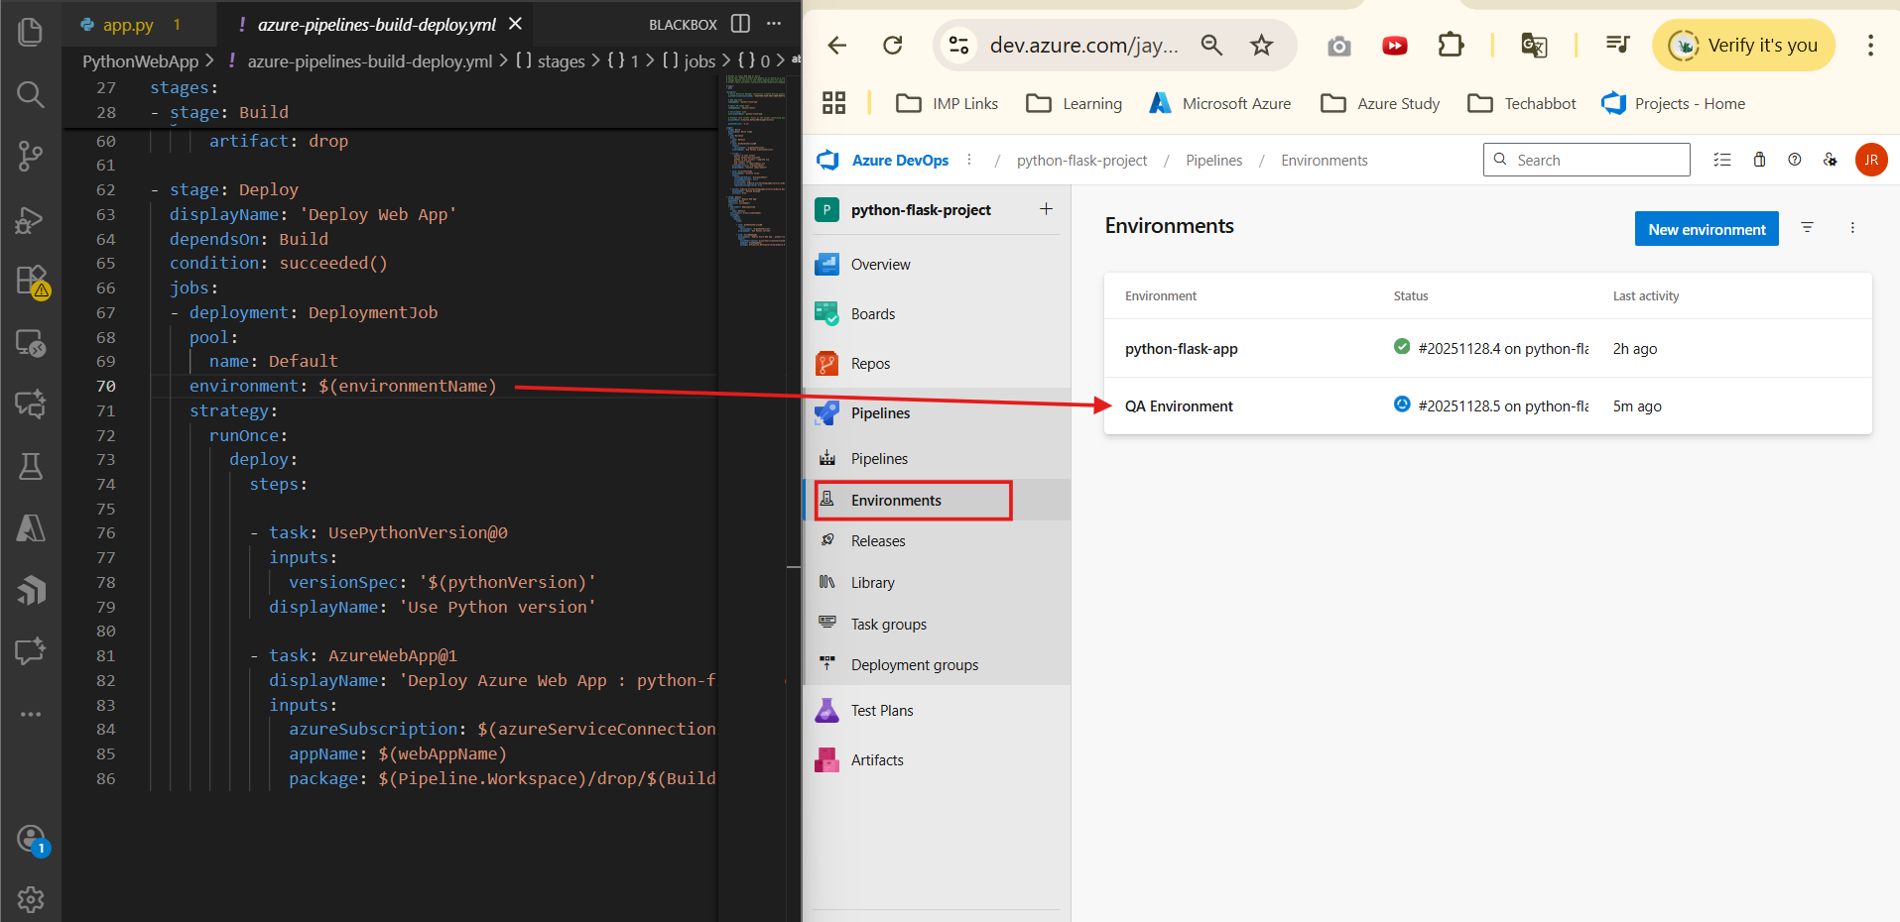

Agent security related issue
